**LOGFILE RESULTS**

**BUILD Log Files Screenshots:**

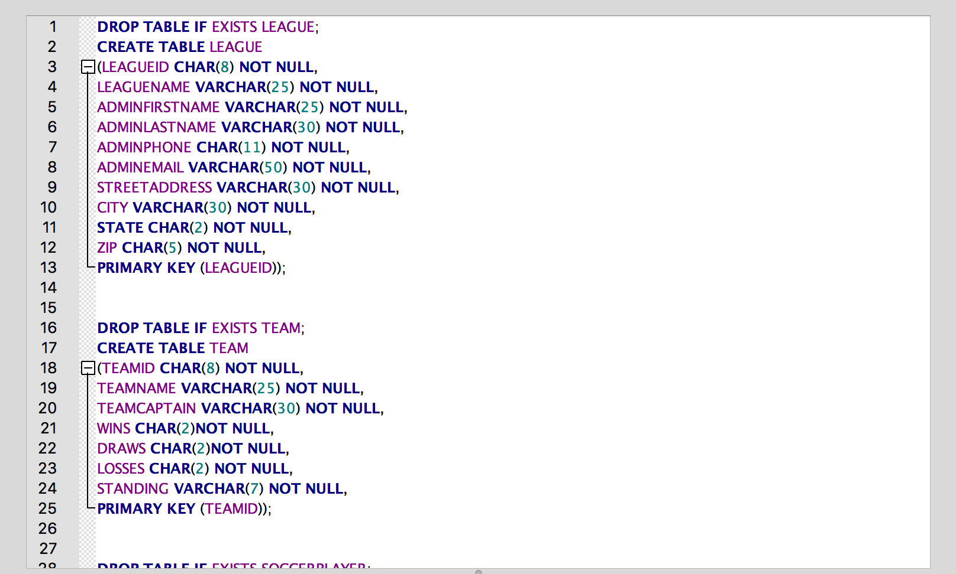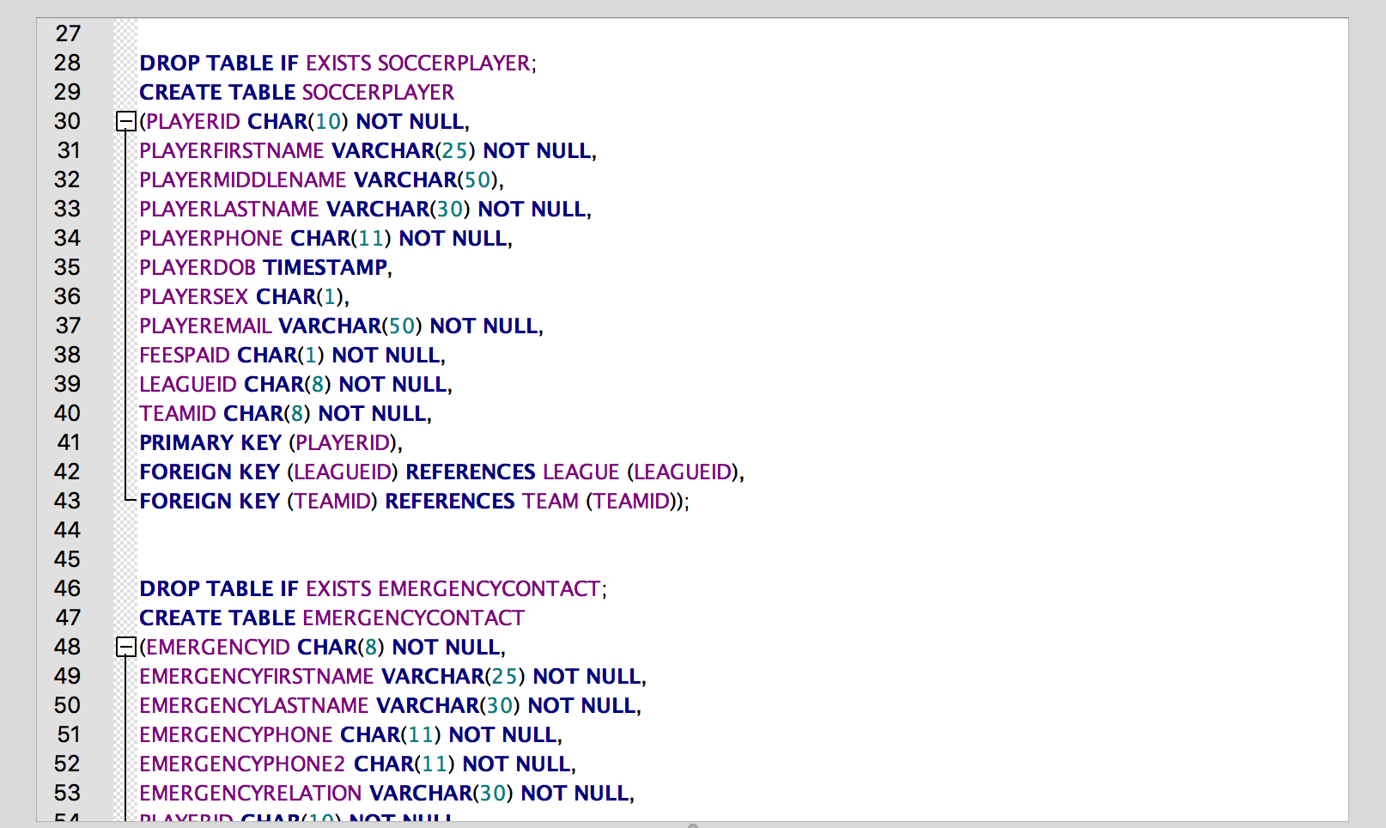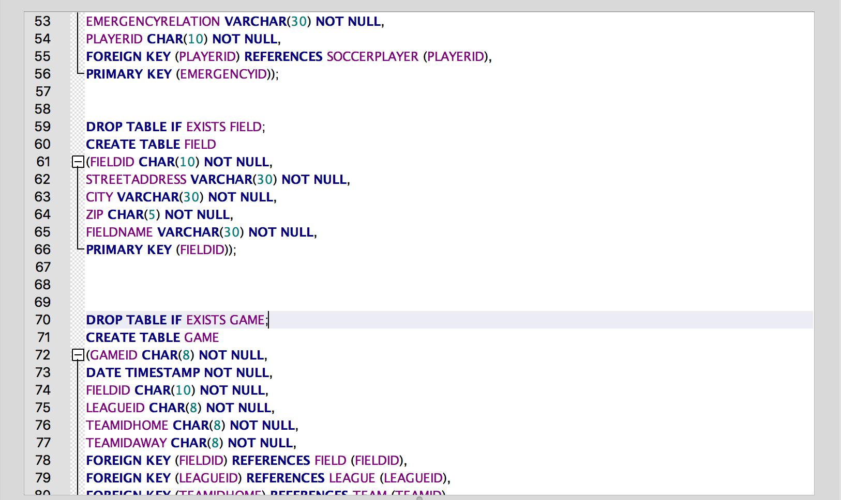

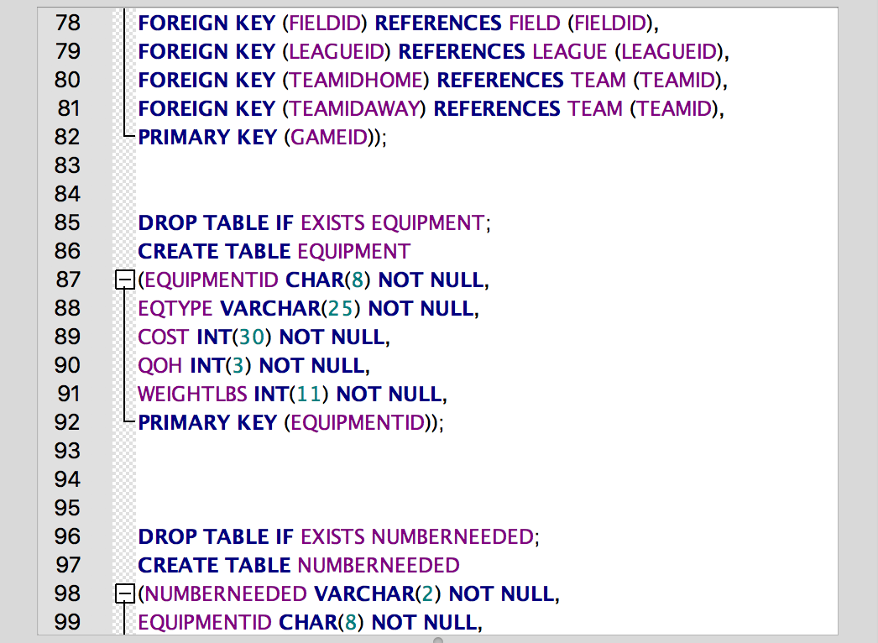

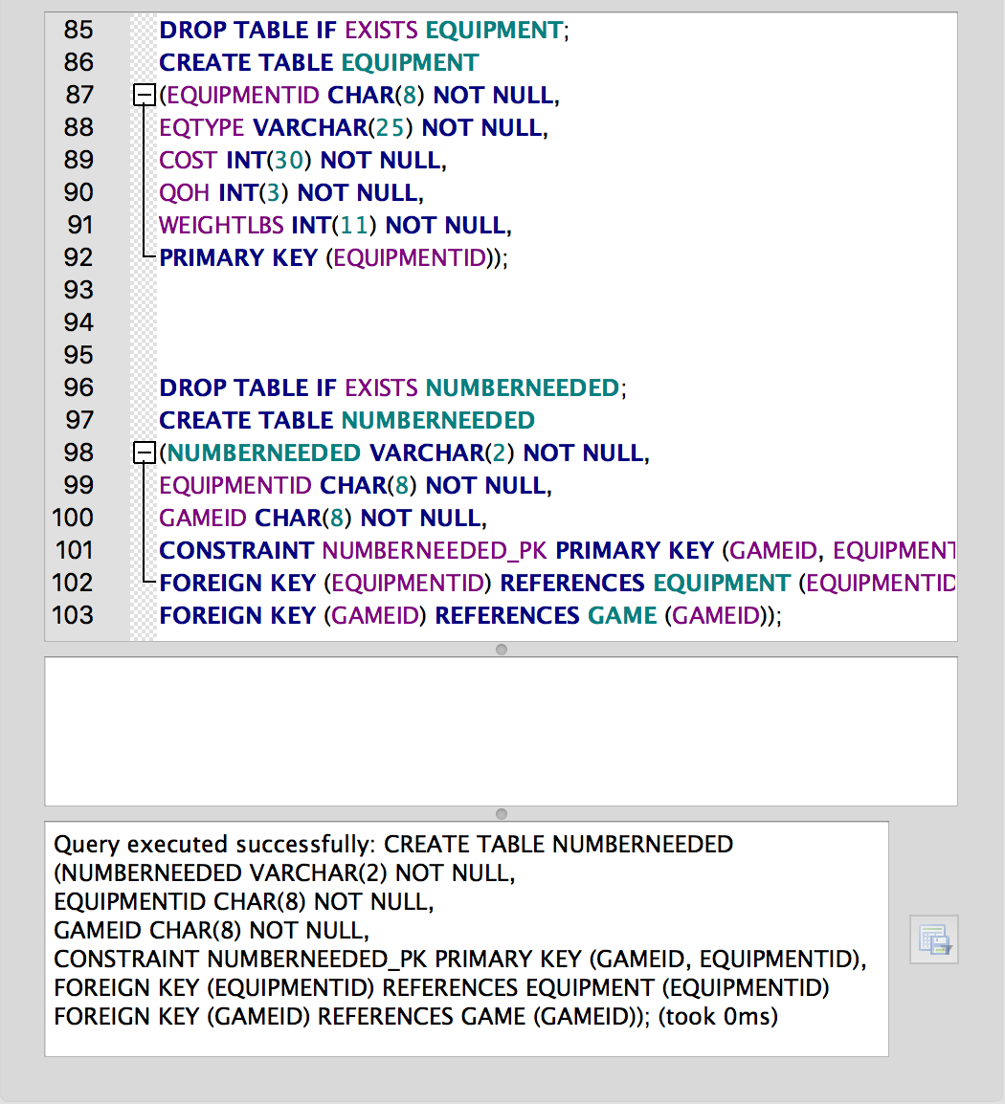

**\*Note. Above is the entire statement that SQLite returns to a user after they create our database.It only shows that the last data table created. Below is a picture of the database structure which proves that all of the tables were indeed created.**

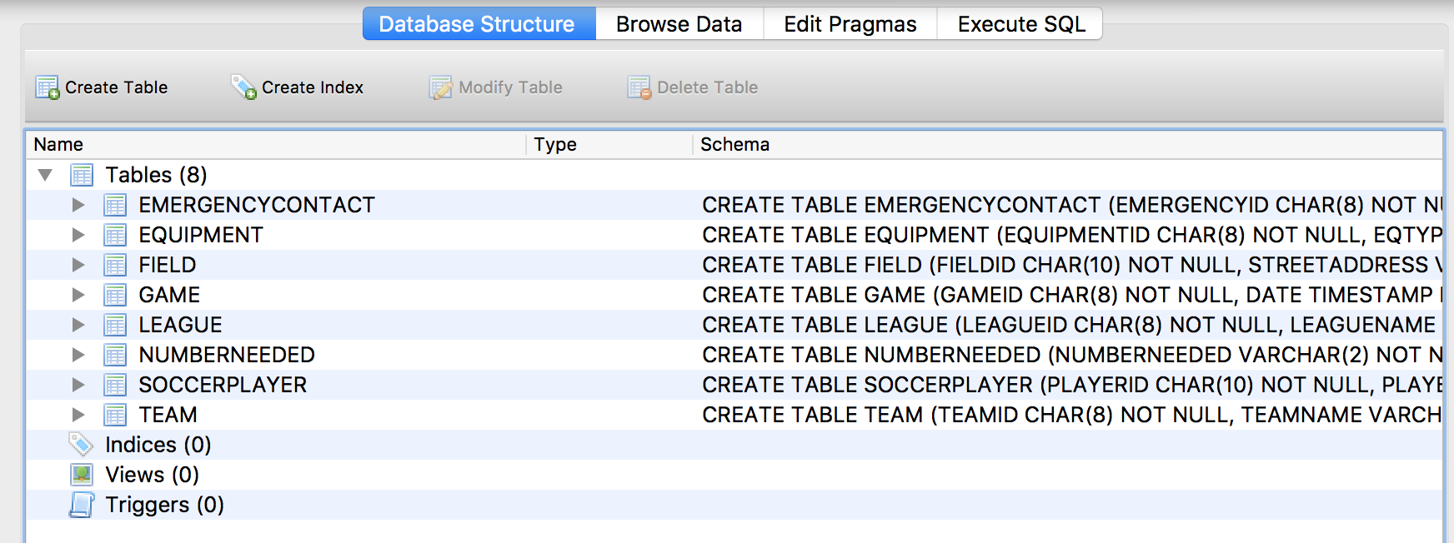

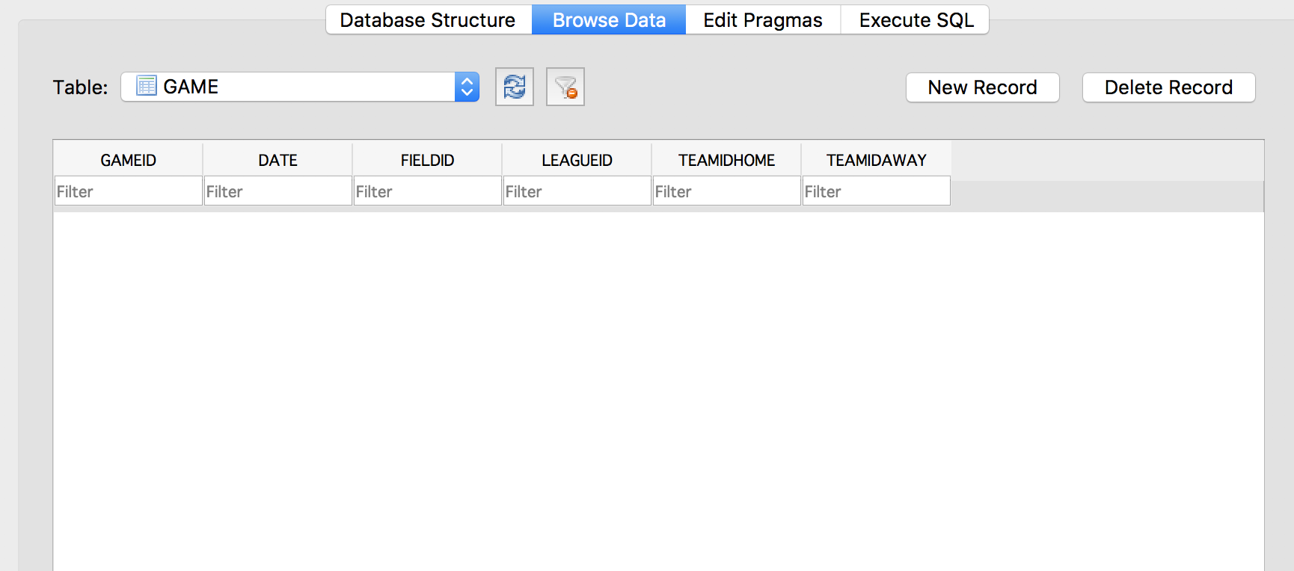

**LOAD Log Files Screenshots:**

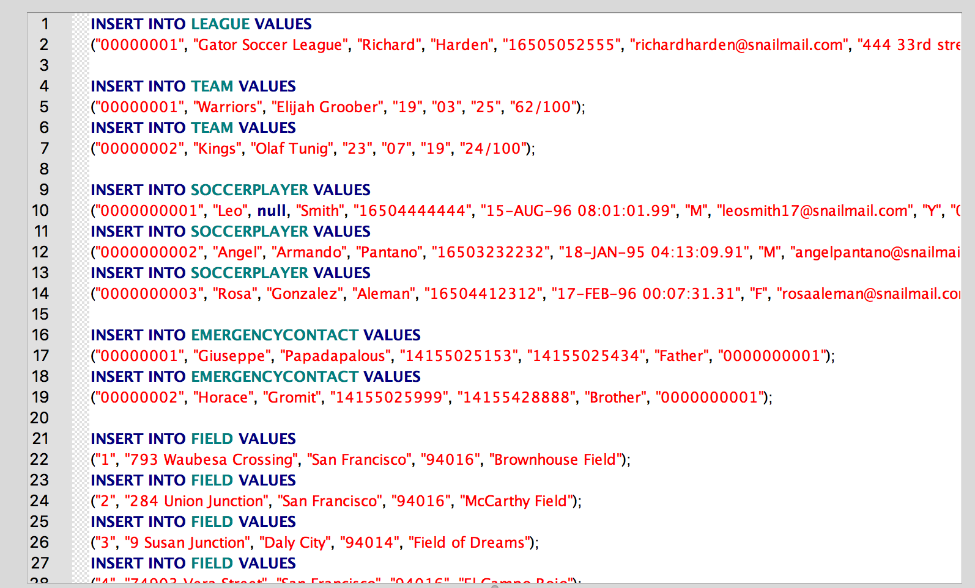

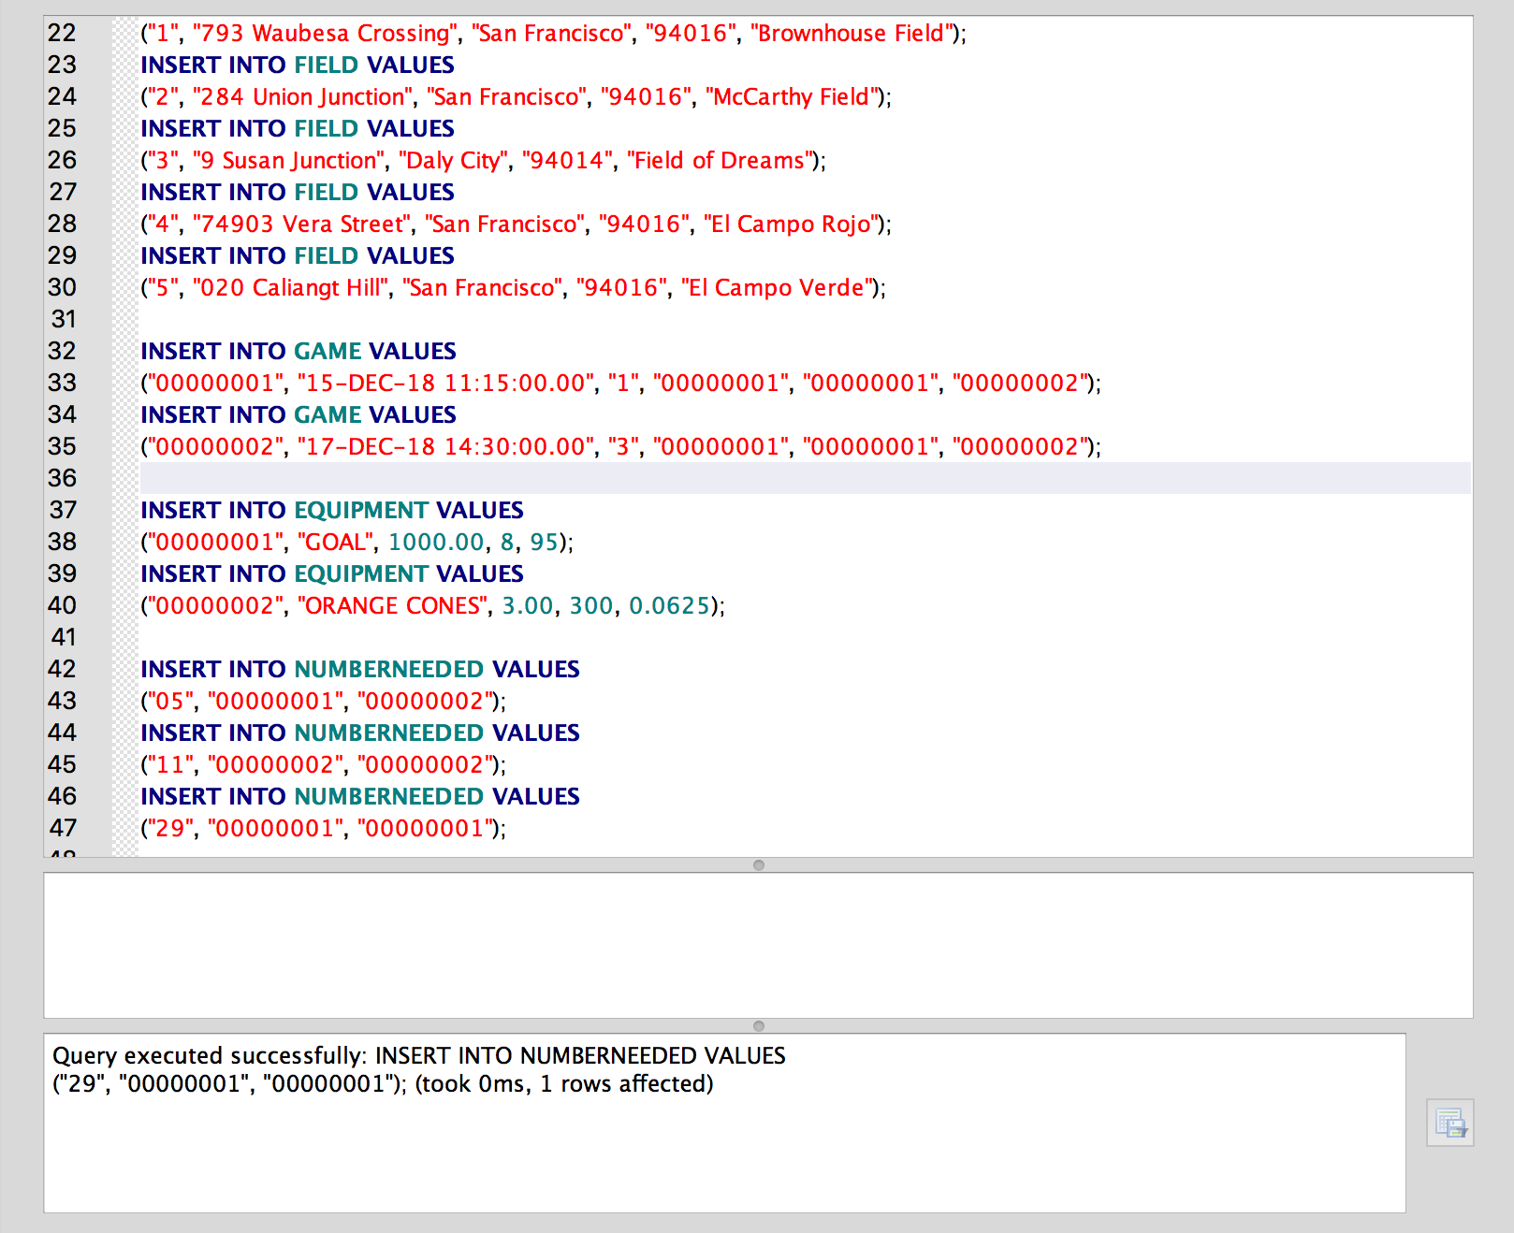

**\*Note. Above is the entire statement that SQLite returns to a user after they create insert data into our database. It only shows that the last data item inserted. Below is a picture of the all 3 rows inserted into NUMBERNEEDED to show that more data was actually inserted.**

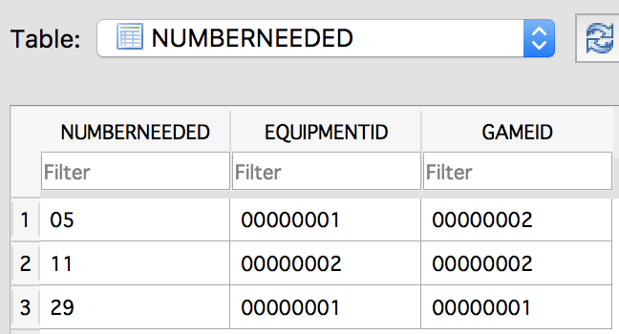

**QUERY Log Files Screenshots:**

**Return the phone numbers of the emergency contact for player by PlayerID**

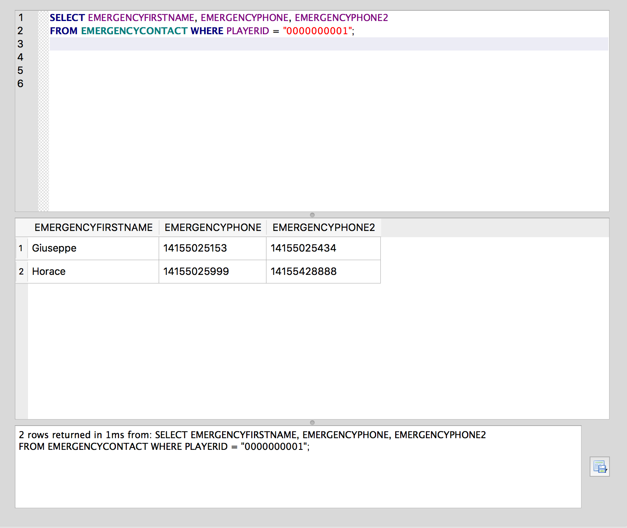

**Return all information contained within the FIELD**

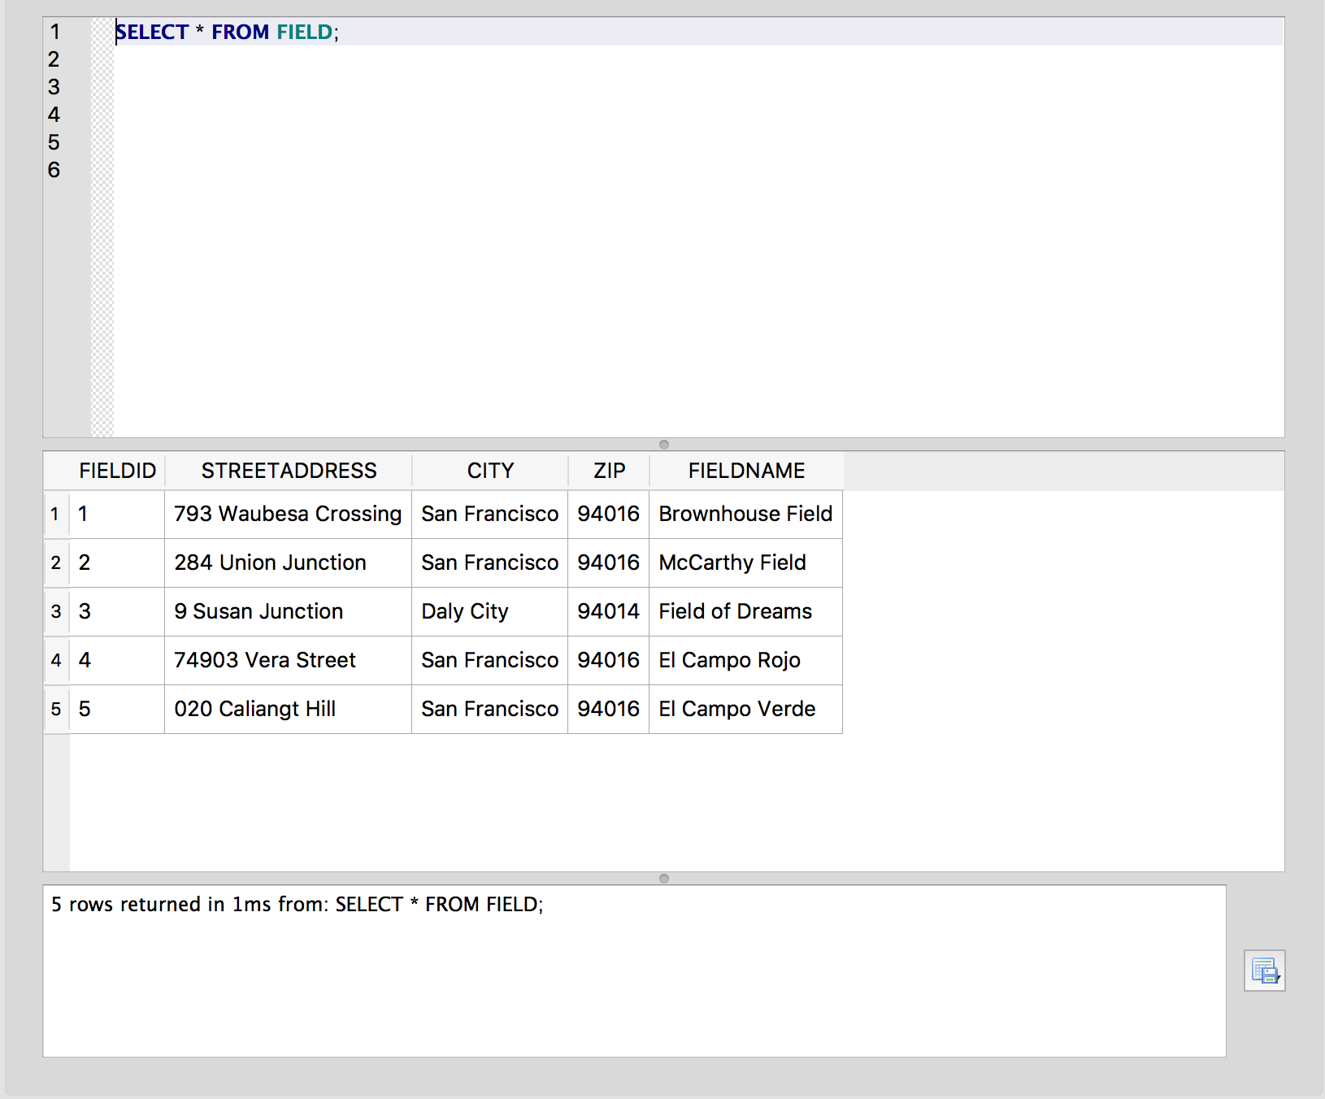

**Return all soccer players who have last names beginning with the letter p**

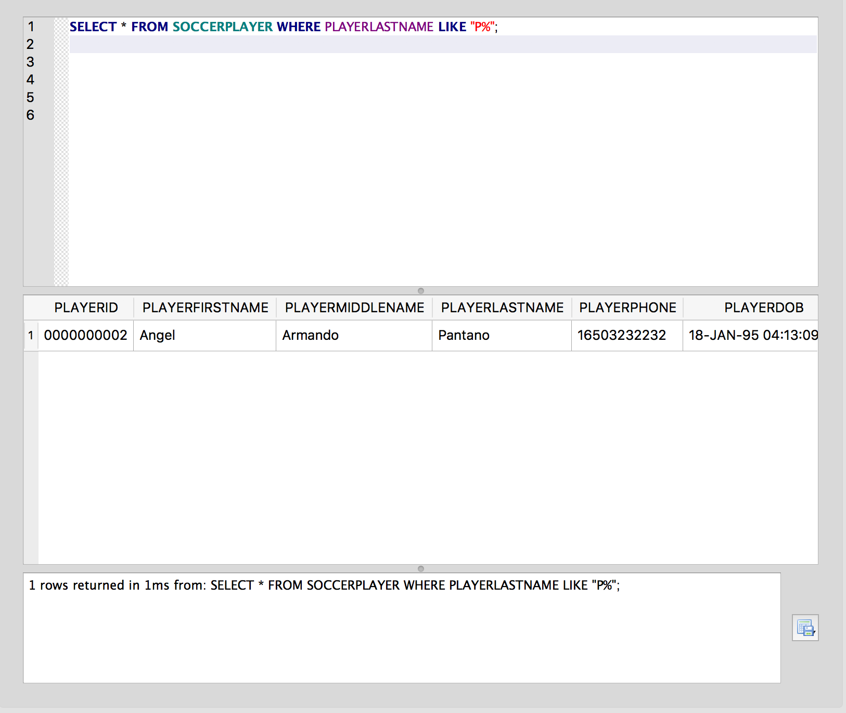

**Return all equipment where the number needed exceeds the quantity on hand**

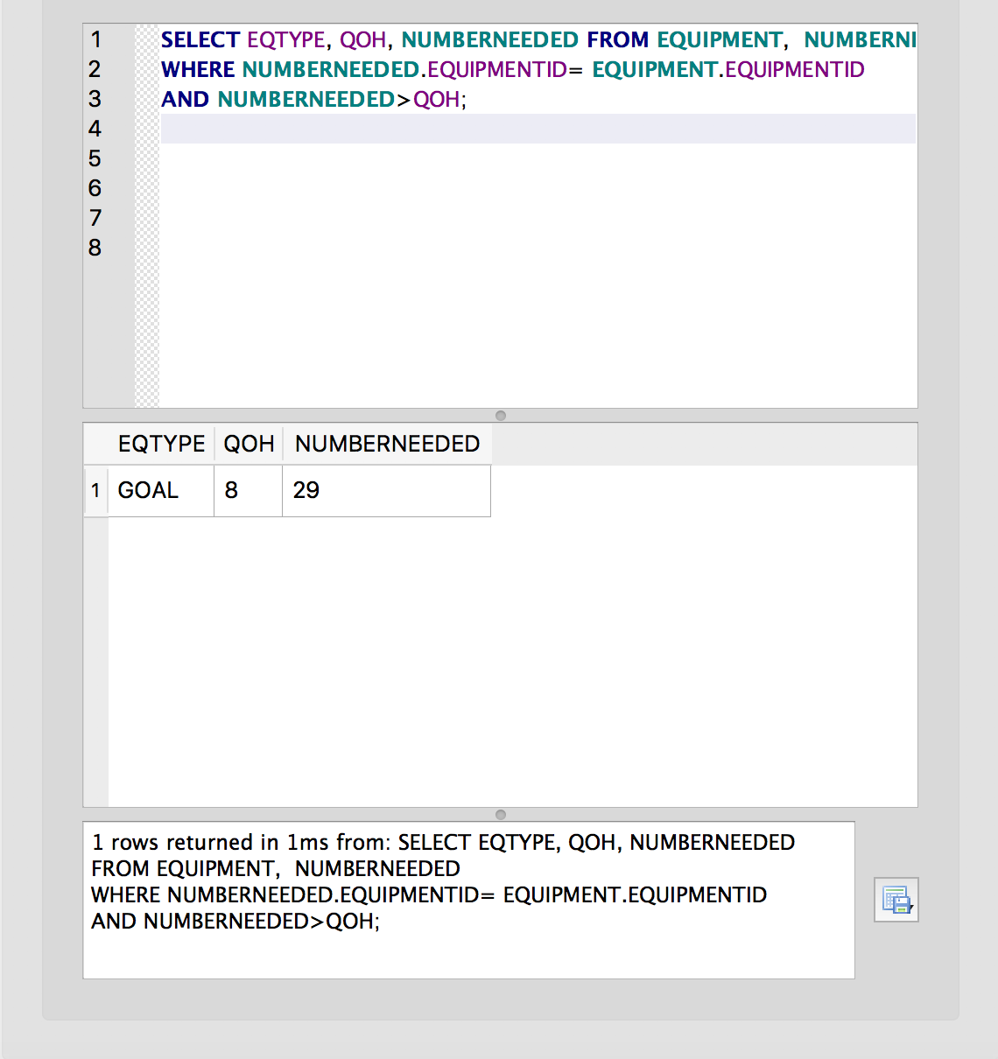

**Return the weight of 2 goals**

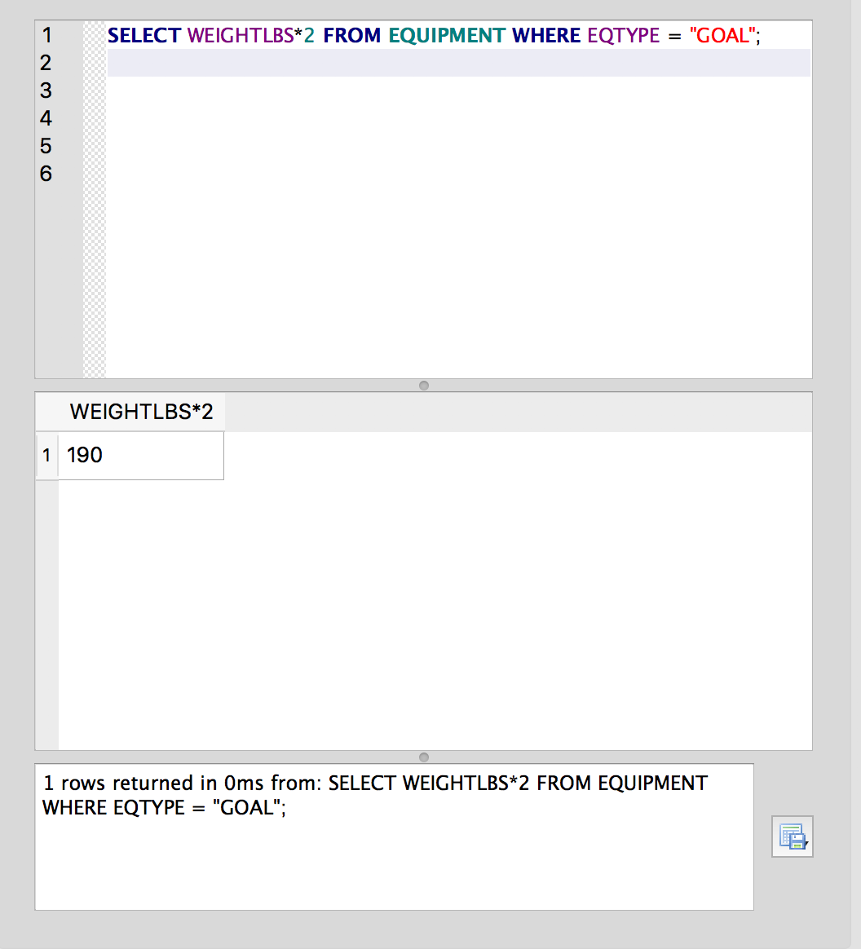

**Return in alphabetical order of team name, the home and away team and some of their attributes in a specific match**

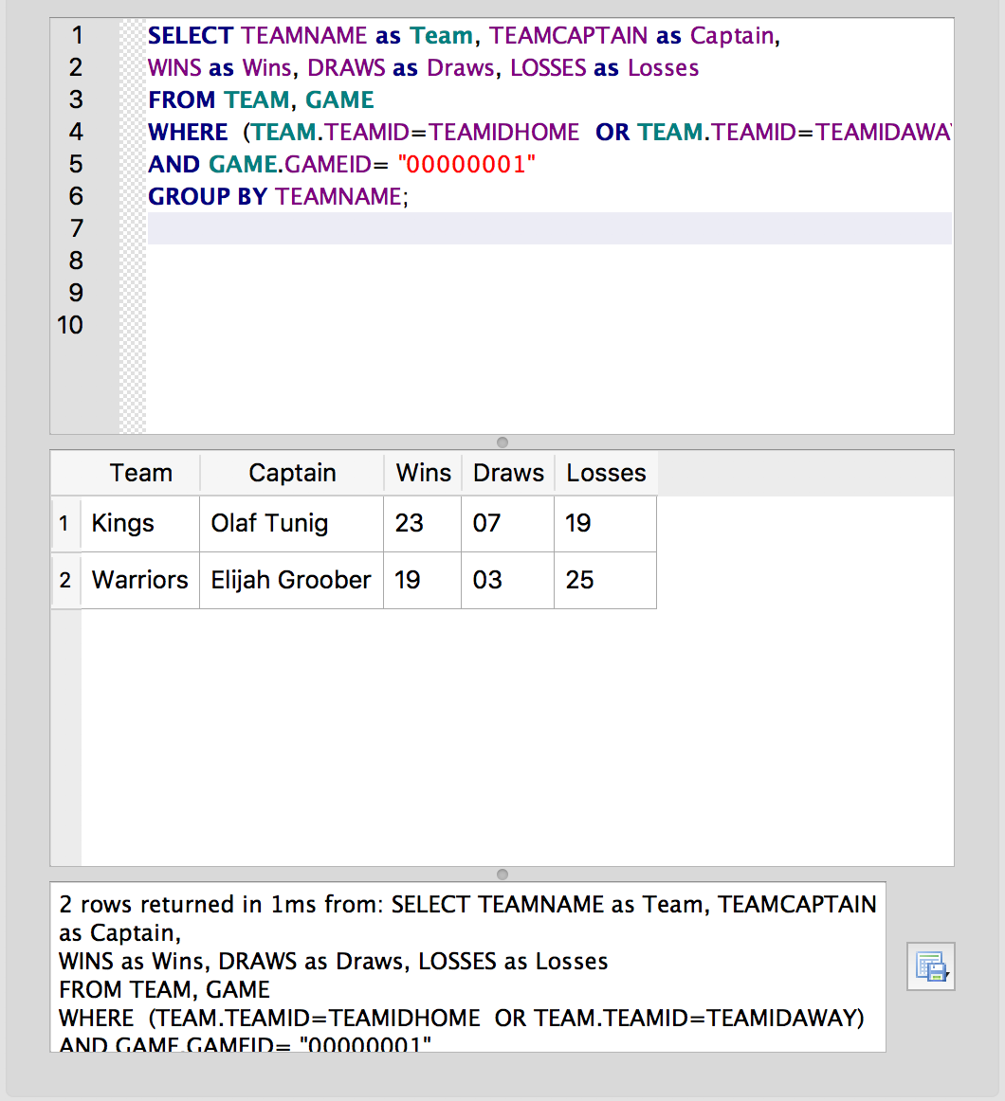

**Return teams in order based on how many wins they have**

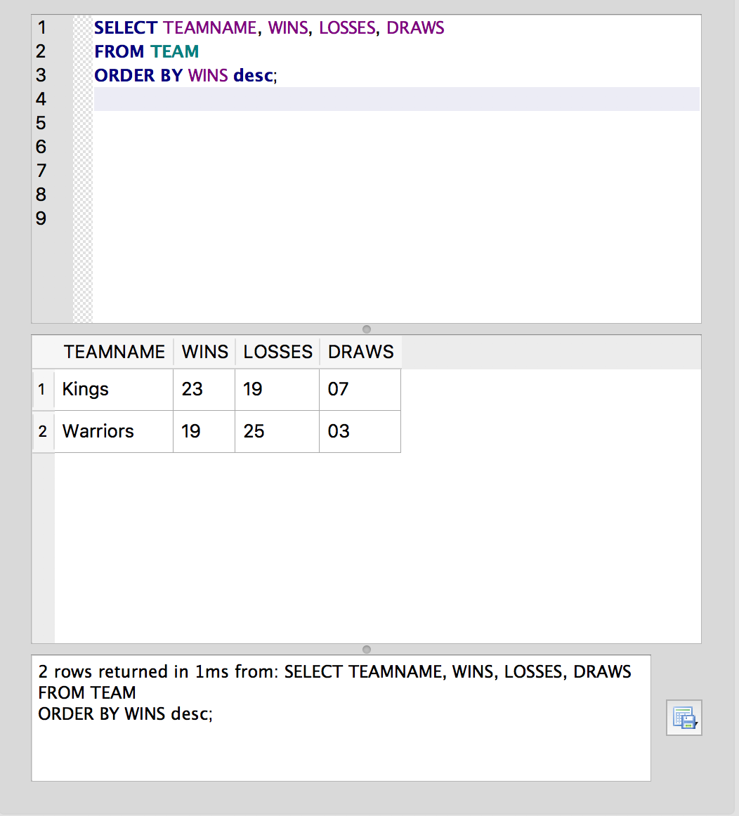

**Return the price of 20 orange cones**

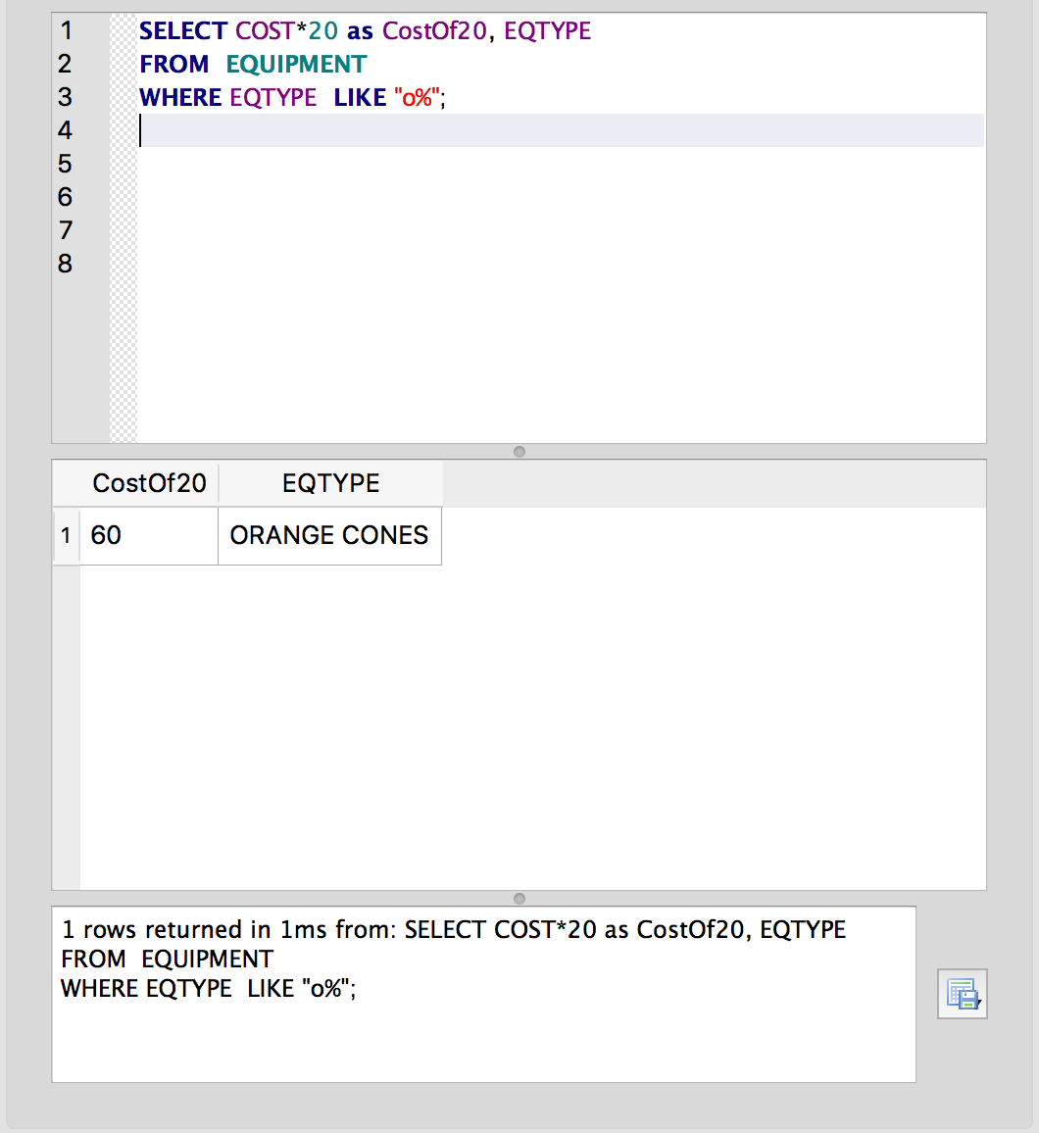

**Return zipcodes of fields without listing the same zipcode twice**

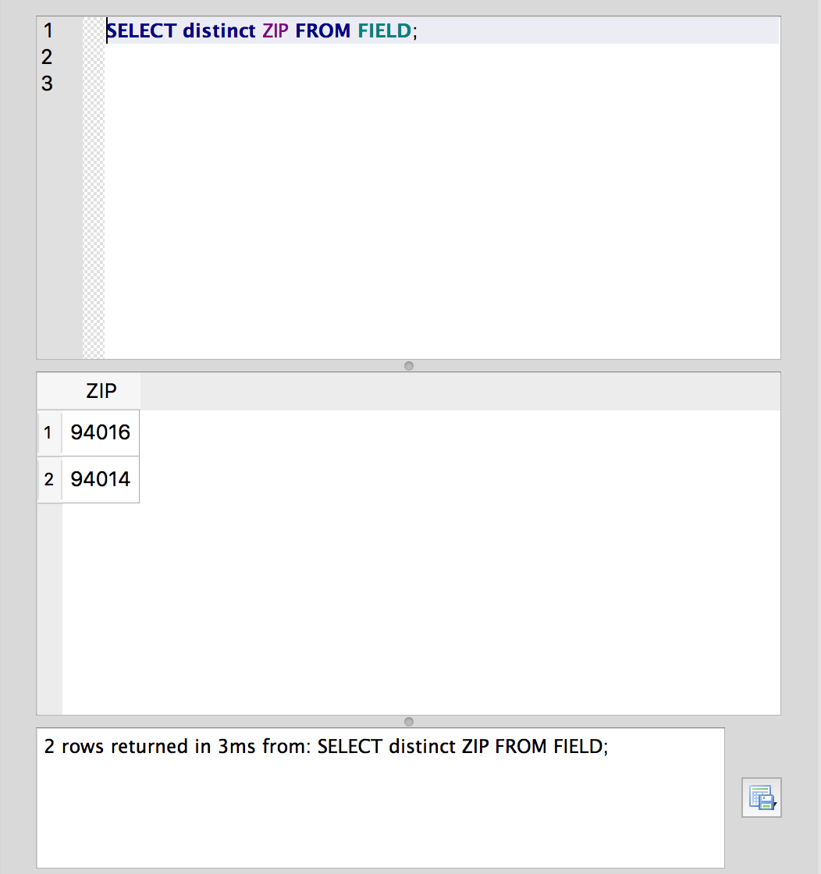

**Return the names of all female players in the leagu and what team they are on**

